Shabbos Stories for
Parshas Ki savo 5781
Volume 13, Issue 53 20 Elul/August 28, 2021
Printed L’illuy nishmas Nechama bas R’ Noach, a”h

For a free subscription, please forward your request to keren18@juno.com
Past stories can be found on the website ShabbosStories.com

Go To My Son-In-Law
For Advice
By Rabbi Sholom DovBer Avtzon

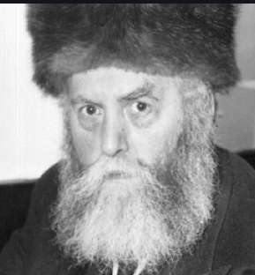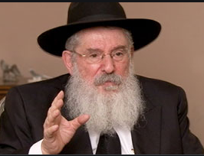
The Frierdiker Rebbe, zt”l Rabbi Nissan Mangel

I heard this story from Rabbi Nissan Mangel.
A Rov who was a student of the Munkatcher, came to the Frierdiker Rebbe (Rabbi Yosef Yitzchak Schneersohn, zt”l, 1880-1950) shortly after WWII, and asked him two things:
Rebbe, I know that you were extremely close to my Rebbe the Munkatcher (Rabbi Chaim Elazar Spira, zt”l, also known as the Minchas Eliezer, 1868-1937),
and being that I can’t ask my Rebbe, I came to ask you. Please give me a brocha that I should have the strength to rebuild my life and start anew. My wife and children were killed in the war, together with many of my extended family, and I went a brocha to be able to rebuild and continue.

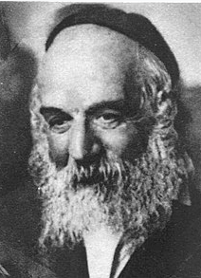
The Minchas Eliezer, zt”l

Secondly, If I am to continue, [I am asking the Rebbe for his guidance, as to] where should I settle?
The Frierdiker Rebbe gave him a brocha to have the strength to continue and then said, concerning the second point, go downstairs and ask my son-in-law for advice.
Following these instructions, the Rov came downstairs and knocked on our Rebbe’s [Rabbi Menachem Schneerson, 1902-1994)door, and told him that The [Frierdiker] Rebbe instructed/advised him to ask him the second question as to where he should settle.

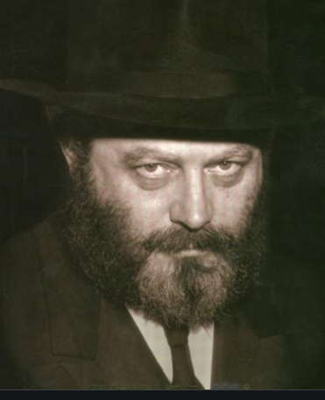
The Lubavitcher Rebbe, Rabbi Menachem Mendel Schneerson, zt”l

The Rebbe replied, I heard that many Jews from Hungary are settling in Argentinia. Being that you are a Rov and a Talmid Chocham, I am positive that they would welcome you and you will be matzliach.
Taking the Rebbe’s advice, he went to Argentina, and like the Rebbe predicted the community was thrilled and honored that such a prominent Rov was considering to settle in their community and they made him as comfortable as they were able to.
The Rov, being a true Rov, set out to establish a school and other things that he saw as a necessity for a Jewish community, and the
community supported all his efforts. Everyone was satisfied with the arrangements.
Some years passed and one day a woman came to the Rov in tears; her wonderful daughter met a young man in college and wants to marry him, even though he is not Jewish. All of her entreaties, promises and threats fell on deaf ears. While in general the daughter was extremely respectful, and would do anything her mother asked, this was the exception.
The Rov called up the daughter and began a conversation. The young lady responded respectfully to all of his questions, but as soon as he broached the sensitive topic, she replied, there is nothing to discuss, I decided that I am going to marry him, and hung up. When he redialed, she didn’t answer.
The mother is sitting there and crying, and the Rov doesn’t know what he can do.
After a few moments, he remembered that the Frierdiker Rebbe instructed him, that if he needs guidance/ advice, he should speak to his son in law, whom is now the Lubavitcher Rebbe.
So he calls Rabbi Hodakov and tells him the story, and concludes, the Rebbe’s father in law, the Frierdiker Rebbe told me that when I need to know what to do, I should ask his son in law, the Rebbe.

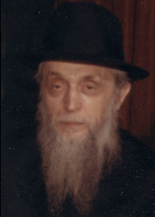
Rabbi Chaim Mordechai Hodakov

He then hears the Rebbe instructing Rabbi Hodakov to tell him, The Rov should tell the young lady, that there is a Jew in Brooklyn who cannot sleep, because of what she is planning on doing.
Hearing this, the Rov was uncertain on how this will work out, as well as how this will solve the problem. The young lady refuses to talk to him, so how is he going to give her this message. And if she does hear it, how would that affect her.

Must Heed the Tzaddik
However, he was a talmid of the Munkatcher and knew that if a tzaddik tells you to do something, you do it, without trying to understand it.
He called the young lady, and to his surprise and delight, she picked up the phone. Knowing that he has her attention for only a few moments, he said to her, “I received a very important message from New York to
give to you, and it will take only a few minutes. Please come to my office as soon as you can.”
The young lady, said she will be there in around a half hour and came.
The Rov told her, after our conversation, I called a very righteous Rabbi, and he told me to tell you that there is a Jew in Brooklyn who cannot sleep, because of what you are planning on doing.
Hearing this she became furious and declared, you deceived me. I know no Rabbi in Brooklyn, and no Rabbi in Brooklyn knows me, this is a lie. There is nothing to talk about.

Goes to Get a Photo to Show the Young Lady
Seeing that she was about to leave, he told her, I will show you a picture of the Rabbi that told me this. Saying that he left the room, noting that he will return in a moment. Going to another office, he took a frame with a picture of the Rebbe and brought it back, saying, this is that person.
Seeing the picture, the young lady began to tremble, and said; the last few nights, this man is coming to me in a dream and instructing me not to marry that person, and warning me of the consequences that would befall us, if we marry.
I never saw that Jew and didn’t know who he is, so I dismissed it. But now that you tell me that he told you this, I see there is truth to it.
She then broke up and the following year married a Jewish man.

Reprinted from the Parshat Matos-Masei 5781 email of The Weekly Story. Rabbi Avtzon is a veteran mechanech and the author of numerous books on the Chabad Rebbeim and their chassidim. He can be contacted at avtzonbooks@gmail.com

Striving for the Minyan

Horav Chaim Toito, Shlita, relates an incident that occurred concerning Horav Moshe Aharon Stern, zl, The Mashgiach of Kaminetz, Yerushalayim. When Rav Moshe Aharon was a lad of eight years old, he became deathly ill. His parents took him to the finest doctors, the biggest specialists.

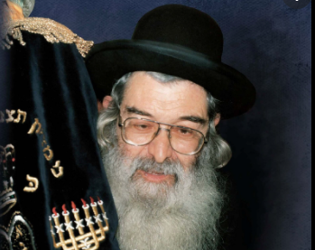

Rav Moshe Aharon Stern

They responded, “Say a prayer.” Tehillim was all that was left for them to do. People recited Tehillim for him around the clock. One day, his father looked at him and said, “Look, everyone is reciting Tehillim for you; everyone is petitioning Hashem for your speedy recovery – everyone – but you.”
The young boy asked his father, “What should I do? I, too, am reciting Tehillim. Is there anything else I can do?”
His father replied, “Accept upon yourself a hanhagah tovah, good practice, a special deed to which you will commit yourself, regardless of the circumstances.” “Does Father have a suggestion for me?” the boy asked. His father thought a moment and replied, “Yes. Accept upon yourself that, upon being cured from this illness, you commit yourself to always daven with a minyan.”

The young boy agreed to accept this policy as a commitment for life. Indeed, he doubled down on his learning, his yiraas Shomayim, fear of Heaven, and strengthened his minyan attendance. He would go out of his way to see to it that, under all circumstances, he would daven with a minyan.
Once he became Mashgiach of Kamenitz, his duties changed commensurably. He now had to shoulder responsibility for maintaining the fiscal obligations of the yeshivah. As the yeshivah grew in size, his obligations also grew. It meant taking off time from the yeshivah to travel to the diaspora to raise funds for the yeshivah. While this presented a problem concerning the time he spent with his students, it also presented a logistical nightmare with regard to his commitment to daven with a minyan.
Therefore, whenever he purchased a ticket to travel out of the country, he made sure that either there was a minyan on the plane or he took a flight that had a layover which afforded him the opportunity to locate and daven with a minyan. Once, on a trip to America, he asked the agent if there would be a minyan at the airport.

No Promise of Finding an Airport Minyan
The response was to be expected, “It is an airport, not a shul.” He could not promise him a minyan, but, if there were enough observant Jewish travellers (which there are at Ben Gurion airport), there would be a minyan. If minyan was so important to him, however, the agent suggested that the Mashgiach take a stopover flight which would allow him a few hours to leave the airport, locate a shul and daven before returning for the continuation of his flight.
Thus, on his next flight to the United States, he booked a flight that had a layover in Amsterdam. He figured he would have sufficient time to take a taxi from the airport to a shul, daven and return in time for his flight to the States. The plane landed in Amsterdam for a two-hour layover. He walked outside the terminal and searched for a taxi/car service.
He had been standing there a few moments when a car pulled up, and the driver asked him in Ivrit, “Where is the Rav going?” Rav Moshe Aharon replied, “I require a minyan.” During the trip, the driver informed the Mashgiach that he lived outside of the city, and every morning he drove into the city to daven and go to work.
After a short while, the car came to a stop in a small alley. They alighted and went into a small shul, in which were assembled eight Jews, who were waiting for two more Jews to complete the minyan. The Mashgiach davened and returned to the airport in time for his flight. He did not miss davening with a minyan.

His Eyes Shone Brightly as He Related the Story
When the Mashgiach related this story, his eyes shone brightly as he would say, “Imagine, eight Jews arise in the morning prepared to daven, knowing that they are eight; number nine must drive in from the suburbs and they must hope that number ten will somehow, from somewhere, materialize. This time they were “gifted” a Jew who was traveling to the United States whose commitment to minyan was so strong that he was ‘availed’ the opportunity to join their minyan that morning.”
We derive from here that just, rotzeh leilech, wanting to go in a certain direction, is insufficient. One must commit strongly to this path. Then he can be assured that, if he commits bah, to it, with strong intention, he will be led there. He must, however, have a bah,” a specific, unequivocal commitment to “it.”

Reprinted from the Parshas Balak 5781 email of the Peninim on the Torah.

The Rebbe’s Concept of
Ayin Tova (Good Eye) and The Chassidic Eye Doctor

In recent times, an individual who exemplified the epitome of ayin tova, a benevolent eye, was the Gerrer Rebbe, zt”l, the Pnei Menachem (Rabbi Pinchos Menachem Alter, 1926-1996). The concept of ayin tova was manifest throughout the bais ha’medrash, with directives that anyone who stood up front during davening allow another Jew to take his place for the following Tefillah.
“In the spirit of the mitzvah of V’ahavta l’reicha kamocha, “love your fellow as yourself,” and because this is the correct and proper way to act, we ask those standing in the front rows during davening (next to the Rebbe) to please allow others also to have the opportunity to stand in these places. He who has an ayin tova is blessed.”
The Rebbe emphasized that rejoicing in the good fortune of one’s fellow is much more than extra-credit; rather, it embodies the principle of avodas Hashem, service to the Almighty, rooted in pure emunah, faith. When a person came to Hillel and asked that the sage teach him the entire Torah on one foot, Hillel replied, “Do not do to another what you will not want someone else to do to you. That is the entire Torah.”
He maintained that abundant parnassah, livelihood, was dependent upon ayin tova. At a tish, festive table/meal, chassidim join together with their Rebbe to listen to his Torah thoughts, sing together and enjoy refreshments. It is an opportunity in which the Rebbe and his chassidim come together for spiritual ascendance and inspiration.

s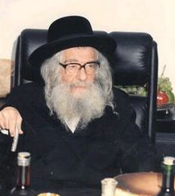

During a tish conducted on Parashas Bo, 1996, a few short weeks prior to the Rebbe’s passing, he said the following: “The Chiddushei HaRim (first Gerrer Rebbe) said that Chazal possessed a keen sense of ayin tova. It was they who instituted that, at a wedding, we recite the blessings beginning with the words, Sameach t’samach reeim ha’ahuvim; ‘Hashem should gladden the beloved companions.’
“They understood that every Jew, even the simplest, was to be considered a beloved companion and should be blessed as such. We must derive from Chazal that we need ayin tova, that we must bless and be melamed z’chus, give one the benefit of the doubt, even to those who are not worthy.”
The Rebbe took the concept of ayin tova to the next level when one of his chassidim, an ophthalmologist by profession, approached him for a bircas preidah, blessing prior to leaving Eretz Yisrael, to speak at an ophthalmology conference. It was Motzoei Shabbos, shortly before the entire Gerrer bais medrash was to usher in Selichos for the Yamim Noraim, High Holy Days.
A long line of chassidim was waiting to receive the Rebbe’s blessing; Jews of all walks of life were all standing at attention, waiting for that precious brachah. The doctor’s turn came, and he explained the reason for his trip.
“What takes place at this conference?” the Rebbe asked.
“Various physicians, many of them specialists in the treatment of illnesses of the eye, speak and present their novel treatments. We all learn from one another,” was the doctor’s reply.
The Rebbe asked, “Tell me, is it possible that a specialist who has discovered a novel approach to the treatment of an illness does not speak because he is not interested in sharing his discovery with anyone? Is it possible that he wants to be the first to innovate his treatment?”
The doctor, who was taken aback by the Rebbe’s insightful question, thought for a moment and replied, “Yes, it is possible.”
The Rebbe implored the doctor, “When you speak, tell your colleagues that your Rebbe in Yerushalayim asked you to convey the following message to this assemblage, ‘Just as our life’s work is devoted to the betterment of each patient’s physical vision, so should our personal vision, how we view people around us, likewise not be impaired. We should view our fellow through benevolent, tolerant eyes, granting everyone the benefit of the doubt. We should seek to help others – rather than look for opportunities to glorify ourselves.”
The doctor’s turn to speak arrived. He rose to the podium and conveyed the Pnei Menachem’s message. When he concluded his short speech, one could hear a pin drop. This had never happened before. Here they were, the premier eye specialists of the world, and they were being admonished by a rabbi in Yerushalayim.
A few minutes passed as the assemblage sat dumbstruck. Then one of the most distinguished physicians, a professor in a prestigious university, a sought-after surgeon who had operated on the power elite of the global community, stood up and walked to the lectern, “My dear colleagues, I have listened to the message of the Rabbi, and I am moved. I must confess that I have with me in my briefcase a paper detailing my latest discovery, a new procedure that will immeasurably transform eye care as we know it.
“Veritably, for obvious reasons, I was not prepared to reveal the contents of this discovery in order to keep all the glory for myself. After listening to our distinguished colleague from Israel, however, I realize that, by not revealing this discovery, I would be depriving thousands of ill patients from this miracle treatment. I defer to the Rabbi’s petition that we think of others – and not of ourselves.” He revealed the discovery to the oohs and ahs of everyone in the room. The Gerrer Rebbe had made a point. We cannot correct someone else’s vision until we first correct our own.

Reprinted from the Parshas Balak 5781 email of the Peninim on the Torah.

Weekly Chasidic Story #1232
Clearly a Pre-Destined Match
From the Desk of Yerachmiel Tilles

The Baal Shem Tov had a chasid who was a wealthy lumber merchant. The chasid would buy lumber and transport it to the bottom of the mountain where the river would carry it to the lumberyard to be sold.
This lumber merchant had a son for whom numerous matches had been proposed. But a strange thing happened -- the moment the boy would see the girl, he would faint.
After a while, the matchmakers all gave up. They considered him a hopeless case. The chasid went to ask the Baal Shem Tov, what to do. The Besht responded simply, "For the right one, he will not faint."

One winter there was a terrible freeze. Conditions became so bad that all the chasid's lumber was lost in the rushing semi-frozen river. So again the chasid went to the Baal Shem Tov to ask for advice, just as he always did. This time, the Besht advised him to become a wandering beggar!
Being a faithful chasid, he accepted his rebbe's instruction and began to travel all over Poland. Whenever he had some time, he would sit in a study hall and learn Torah.
One day, while he was sitting in the study hall in a certain town, a resident of the town came up to him and asked, "How much do you earn in a day?"
"A ruble and a half."
The resident then said, "I'm impressed with your dedication. I will pay you two and a half rubles every day if you will study Torah in my house instead."
The chasid readily agreed - how could he pass up such a generous offer!
A few weeks later he heard the husband and his wife crying in the middle of the night. The next day, wanting to help, he asked if there was any way he could repay them for their kindness.
After some hesitation they told him that they had a beautiful and kind daughter, but every time she was introduced to a man she fainted, they explained tearfully. They had summoned all the best doctors, but alas, none could help their daughter.
The chasid replied, "Maybe my Rebbe, the Baal Shem Tov, can help. Come," he said, "let us travel together to Mezibush, and we will see what develops."
The desperate couple did as he suggested and within two weeks they stood before the holy Baal Shem Tov. Before the Besht spoke to the husband and wife, he turned to the chasid and asked him to bring his wife and son and wait with them in the next room.
The Baal Shem then listened to the story of the husband and wife and asked, "Can you provide a good dowry for your daughter?"
"We certainly will provide a proper dowry," they answered. They told the Baal Shem how four years earlier, during a bitter frost, they awakened one morning and found hundreds and hundreds of pieces of lumber in their yard. Try as they might, they could not find the owner of the lumber. So, they sold it to the lumberyard and had made a fortune.
The Baal Shem then asked the chasid to come in with his wife and son. They entered the room.
The son looked at the daughter.
The daughter looked at the son.
Neither fainted!
"You see", said the Baal Shem Tov with a beaming smile, "The money this girl's parents received from selling the lumber actually belongs to this poor chasid, the father of this boy. And all of these events occurred only so that this girl and this boy should meet. MAZEL TOV!"
~~~~~~~~~~~~~
Source: Adapted and supplemented by Yerachmiel Tilles from the rendition in a Chabad women's seasonal publication that is no longer available, called "Permeations" (Vol. 3 No. 3 - Sivan 5765 / Spring 2005), based on the version on //rebshlomo.com.
Connection: This Shabbat is also a Jewish holiday: the 'Fifteenth of Av' - "Matchmaking Day"!
Biographical note: Rabbi Yisrael ben Eliezer [of blessed memory: 18 Elul 5458- 6 Sivan 5520 (Aug. 1698 - May 1760 C.E.)], the Baal Shem Tov ["Master of the Good Name"-often referred to as "the Besht" for short], a unique and seminal figure in Jewish history, revealed his identity as an exceptionally holy person, on his 36th birthday, 18 Elul 5494 (1734 C.E.), and made the until-then underground Chasidic movement public. He wrote no books, although many works claim to contain his teachings. One available in English is the excellent annotated translation of Tzava'at Harivash, published by Kehos.

Reprinted from the Parshas Va’eschanan 5781 email of KabbalaOnline.org, a project of Ascent of Safed.

Meeting by Accident
By T.H.

My job that is I am a Rabbinical advocate [toen]. I met a man in the street who very much wanted to talk with me and his flight was leaving the next day so he had no time to come back.
I explained to him that I was hurrying to do some things and it was not possible for me to speak with him in the street especially since at that moment I was trying to call my driver without success.
The man saw that I was in a hurry and he wanted to know where I was rushing to. I explained that my driver was not responding, and I had to be at a number of meetings, and so my mind was not settled enough to listen to him.
The man offered to be my driver and we could talk on the way… I accepted the offer and we left together both of us pleased. We also talked about the belief in hashgacha pratis (divine Providence), for example, what I thought was a nuisance was actually my salvation, and my problem with the driver who was stuck in traffic and his cell phone broke, since the man had no other chance to talk with me at all. At one of the stops, I went up to one of the Tzaddikim and the driver asked to join me. He was able to receive a beracha (blessing) from him and when we left, he told me that he had tried with all his might to get a beracha from him, and now Hashem had arranged for him to get the beracha, and he felt that one of the reasons that I did not have a driver was so that he could receive a beracha from that Tzaddik.
We agreed that the faith in hashgacha pratis brings us to have gratitude towards the Creator, and this is how we can attain avodas Hashem (our service to G-d) with joy and a good heart.

Reprinted from the Parshas Va’eschanan 5781 email of Tiv HaKehila.
The Ignorant Groom’s Transformation
By Hillel Baron

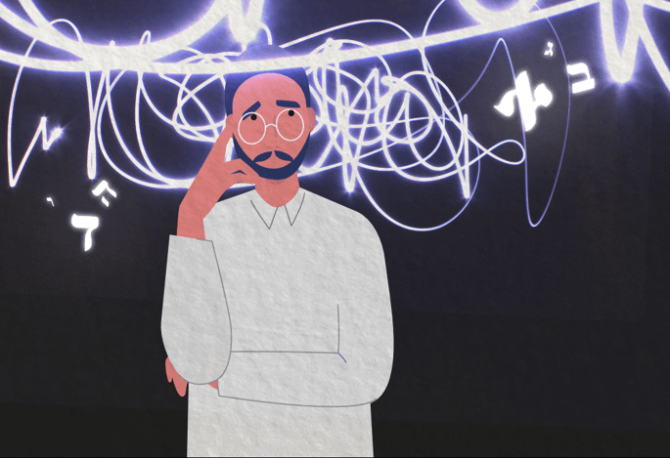

Rabbi Avraham Abish of Frankfurt¹ was born into a family of great Torah scholars, but he did not quite fit in. He experienced learning challenges, including trouble with reading. Despite his difficulty participating in Jewish life, he was a sincere young man who developed a strong awe of Heaven.
His father understood that he could not marry into a family of scholars, and arranged a match with the daughter of a wealthy, G-d fearing businessman from the city of Mezeritch.
The custom in those areas was that during the festivities surrounding a wedding, the groom would lead the Grace After Meals, reciting the final words of each blessing aloud. His brothers worried that his lack of reading skills would embarrass them, so they made a point of tutoring him, and helped him memorize the blessings.
During one of the meals before the wedding, while surrounded by his family, he was asked to lead the blessings, as preparation for the wedding festivities. But his mind went blank, and he could not remember what he had memorized.
Frustrated and ashamed, his brothers scolded him and told him that he was an “embarrassment to the family.” Crestfallen, he left the table and went off into the forest, where he prayed to G-d like never before.

Dreamt of Meeting an Impressive-Looking Man
Exhausted, he fell asleep and dreamt of an impressive-looking man who told him, “I will bless you to succeed in scholarship, provided you remain humble, as you always have been. Whenever I appear to you, you will listen to what I teach you and then repeat it.”
The wedding took place on a Monday. On Tuesday morning, the groom was sent off to pray in the town synagogue. After prayers, the holy man from his dream appeared to him and spoke to him, so the young groom got up to speak in front of the people. He delivered a beautiful dissertation on an obscure subject of Talmud, and everyone crowded around him, immensely impressed by his teachings.
Meanwhile, his father and family were waiting for him, and wondered why he was so delayed. They went off to the shul to see what was going on, and were amazed to see him delivering a speech.
“He has finally revealed his potential as a great scholar and a tribute to the family,” they said to each other. “Maybe we should see about ending this marriage, as he can now marry into a great rabbinic family like ours.”

Refused to Leave His Wife
But the groom, of course, refused and said that the woman he had just married had clearly been ordained for him by G-d. He went off with his wife to study in the Torah academies of the day, and became one of the great scholars of Israel.
Nevertheless, he always retained his humility. When signing his name, he would write: “Avram ‘hu—he is’ Avraham.” This reminded himself and others of how G-d chose to transform Abraham our Forefather into a great man, changing his name from Avram to Avraham, which carries the meaning, “Father of multitudes of nations.”² The hint was that the same applied to him: he had been called upon by G-d, and had been transformed into the scholar he now was.

Are we fully aware of the potential of prayer to change our innate capabilities? How do we treat those in our lives who live with learning challenges—are we proud of how they deal with that experience? After we achieve success with something which was extremely difficult for us, do we remain the same sincere person whom we were before?
FOOTNOTES
1. Circa 1690-1769. He served as rabbi of multiple communities, culminating with the position of head of the rabbinical court in Frankfurt.
2. Genesis, 17:5.
Reprinted from the Parshat Va’etchanan 5781 email of Chabad.Org Magazine.

